IMPACT Lexicon Tool



IMPACT Lexicon Tool

The IMPACT Lexicon Tool is a tool for corpus based lexicon making.
The tool allows the user to upload corpora that can be used for attestation based lexicon making.

The tool is currently a preliminary beta version offering only basic functionality. Future versions will have more elaborate features.

Installation
The tool is an AJAX application designed for Mozilla Firefox (though other browsers may work as well). It uses a MySQL database, and is written in PHP.

PHP
A webserver should be running that can handle PHP requests and the source code of the tool should be placed in a directory for which this PHP support is turned on.
The tool was tested on PHP 5.1.6 running on Red Hat Enterprise Linux Server release 5.2.

PHP memory limit
Because PHP reads through all the files it is advisable, when large files have to be processed, to set the maximum memory for PHP scripts to a value higher than what it usually is (16M in our case).
This can be done by setting the memory_limit variable in the php.ini file:

memory_limit = 256M ; Maximum amount of memory a script may consume

Of course, the 256M can be any value you like.
It may be necessary to restart the webserver for this change to have an effect.

Uploading multiple file, PHP zip support
PHP can not read directory listings, so to upload multiple files at once zip files can be used. This is only possibly if PHP has its zip functionality enabled. Please refer to the PHP documentation for your version.
As a reference, our phpinfo() shows this:
zip

Zip | enabled
Extension Version | $Id: php_zip.c,v 1.95.2.6 2007/05/19 22:35:49 pajoye Exp $
Zip version | 1.8.10
Libzip version | 0.7.1

MySQL
In order to set up the MySQL database for the tool root access is needed to the MySQL server.
The tool was tested on MySQL 5.0.45, running on Red Hat Enterprise Linux Server release 5.2.

Create a database
The tool expects a MySQL database to be there with the right table structure. A database can be created in MySQL by running this query:

mysql> CREATE DATABASE myLexiconDb;

In this query the italic part should be replaced by your own database name.
The right data structure for the tool can be created by using the SQL script for setting up an empty database that comes with the distribution of the tool. On the command line you can do this by executing the following command:

% mysql –u root –p myLexiconDb < emptyLexiconDatabase.sql

Make a MySQL user
When a database has been created a MySQL user should be added. This can be done by running the following statements:

mysql> GRANT ALL ON myLexiconDb.* TO 'newUser'@localhost IDENTIFIED BY 'password';

mysql> GRANT ALL ON myLexiconDb.* TO 'newUser'@'%' IDENTIFIED BY 'password';

mysql> FLUSH PRIVILEGES;

Again, the italic parts in the queries should be set to your own desired values.

Fill the user table
The entire database can be empty at start up but for the user table which needs at least one row. New users can be added with the following statement:

mysql> INSERT INTO users (name) VALUES ('Amy'), ('Billy'), ('Duffy'), ('Ella');

Set group_concat_max_len
There are some queries, most notably the one that gives the overview of the type-frequency list, that make extensive use of MySQL's built in GROUP_CONCAT() function. The result of this function can quite easily become larger than the default length that is allowed. It is advisable therefore to set this value to its maximun length by issuing the following statement:

mysql> SET GLOBAL group_concat_max_len = @@max_allowed_packet;

Adjust to local environment
There are two places in the code that need to be adjusted to the local environment.

lexiconTool.php
This file contains a form called loginForm stating the available databases. This form should be altered so it states all the available databases.

globals.php
The file php/globals.php contains all environment specific variables.
The global database parameters should be modified to match the values used in the 'Make a MySQL user' part above.
The document root can be set to any available directory, as long as this directory is readable and writable for the tool. It is highly advisable to avoid having this directory in the same directory the application is in because it might accidentally be thrown away when a new version of the tool is installed.
The tokenizer directory should simply point to the directory the tokenizer is in.

The interface

Log in screen
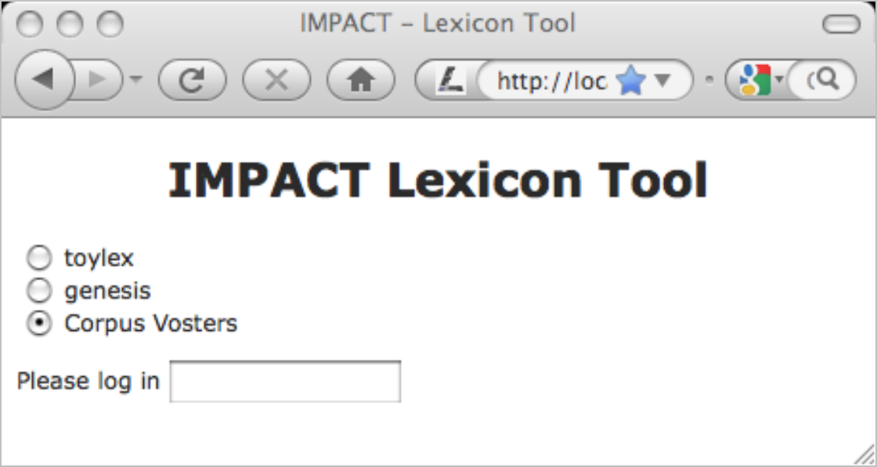
Figure 1 - screenshot of the Impact Lexicon Tool inlog screen
The first screen is an log in screen. The different choices listed here should have been set in the first 'Adjust to local environment' step described above.
The user simply types in his/her name and chooses a database to work on.

Corpora screen
In the next screen the user can choose a corpus to work on. Also corpora can be deleted, new corpora can be added and files can be added to or deleted from corpora.

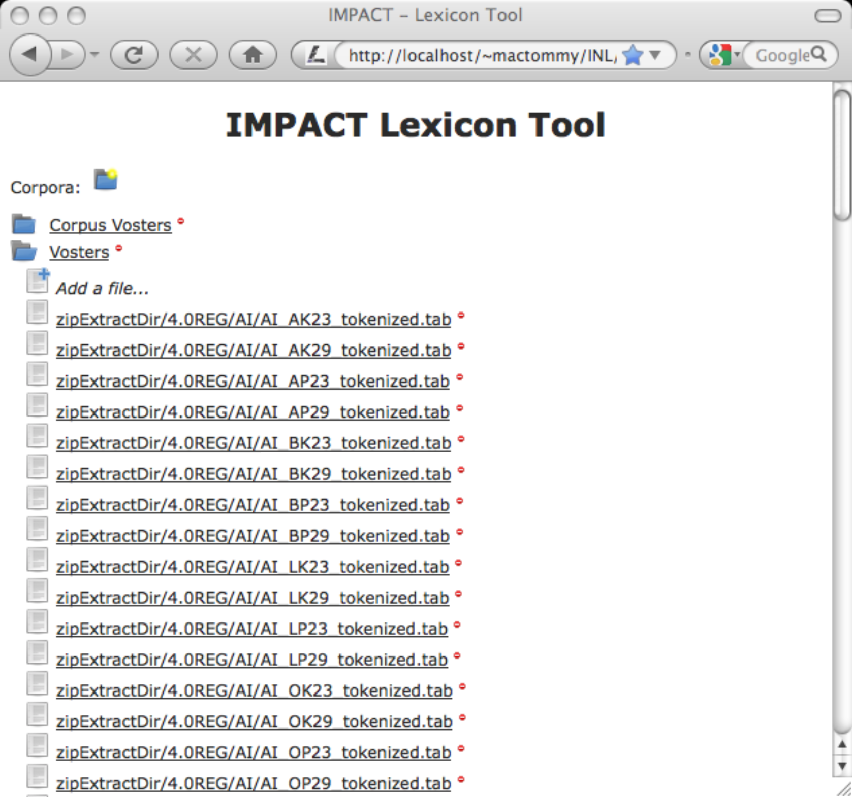
Figure 2 - screenshot of the Impact Lexicon Tool corpora screen

Corpus mode vs document mode
The tool can work in two modes: corpus mode and document mode.
By clicking on a corpus name the tool will load in corpus mode (i.e. the user will work on a list of word forms for an entire corpus). By clicking on a document name the tool will load in document mode, which means that only that particular document is taken into account.

Loading documents
Documents can be loaded into the tool one by one or a lot of them together in a zip file.
Any untokenized document will be tokenized by the tokenizer integrated in the tool. However, it is also possible to upload tokenized documents which will be recognised as such automatically. This is particularly handy if you need your tokenization to be different from what the integrated tokenizer does.

Main screen

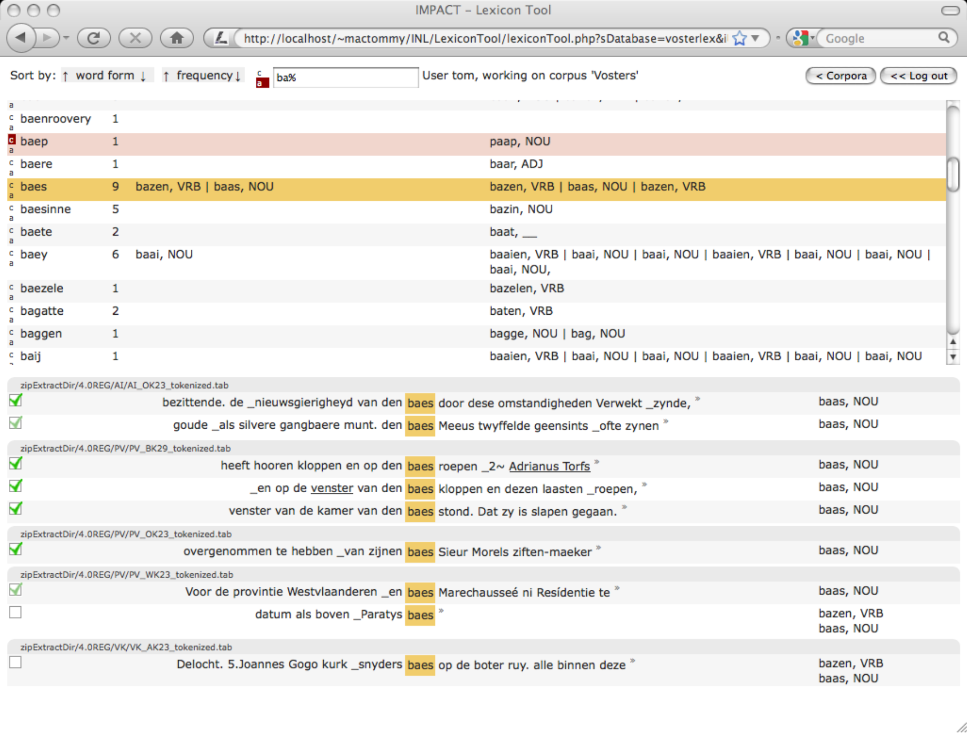
Figure 3 - screenshot of the Impact Lexicon Tool – main screen
In the screenshot above we see the tool in action. It is running in corpus mode, which means that the user selected a collection of documents to work on, rather than just one. In the latter case the tool would have run in document mode.
The interface is divided in three main parts.
- Top bar
For sorting and filtering the words presented
- Middle part
Shows the type-frequency list plus current attestations in the corpus and database.
- Bottom part
Show the word forms as they appear in the corpus.

We will go through the different parts of the screen below.

Top bar
Figure 4 - partial screenshot of the IMPACT Lexicon Tool – top bar

Sorting
Using the arrows at the left side of the bar we can sort the type frequency list in the middle part by alphabet (ascending or descending) or by frequency (ascending or descending).

Showing/hiding word forms
Just left of the filtering box there are two buttons (labeled c and a in corpus mode, or d and a in document mode). Words can be hidden for a particular document, for an entire corpus and even forever. This means that the tool will not show cerain words, unless these buttons are used. If the c button is on all the words that were actually hidden for the current corpus will be shown again (though visibly marked as being hidden, as the word 'baep' in the example screenshot, see next section in showing/hiding word forms in the middle part).
If the a button is switched on (as it is in the example screenshot) all words that were hidden will be shown again.
By default, these buttons are switched off (i.e hidden word form are not shown).

Filtering
The filter in the filterbox will be applied to the word forms in the type-frequency list. You can filter on word form beginnings, endings or, in fact, anything in between. The filter is directly passed to the MySQL LIKE operator.
For not-MySQL-guru’s: the most frequently used wildcard is % which means any sequence of characters. So %a% means: any word form matching an arbitrary sequence of charcaters, then an a and then posiibly some more characters. So ball would match, but also ant or pizza or indeed any word form with an a in it (including the string a itself). The example ba% means all the word forms starting with ba… (so ball woud match again, but abacus wouldn't).
The filter is not case sensitive.
For further documentation please refer to the MySQL documentation.

Current user, corpus. document
At the right side of the filtering box are the name of the current user and the name of the current corpus (when in corpus mode) or document (in document mode).

Log out
At the right side there are two buttons. One, labeled Corpora, for going back to the available corpora in the current database. The other one, labeled Log out, gets you back to the start screen where a database can be selected.

The middle part
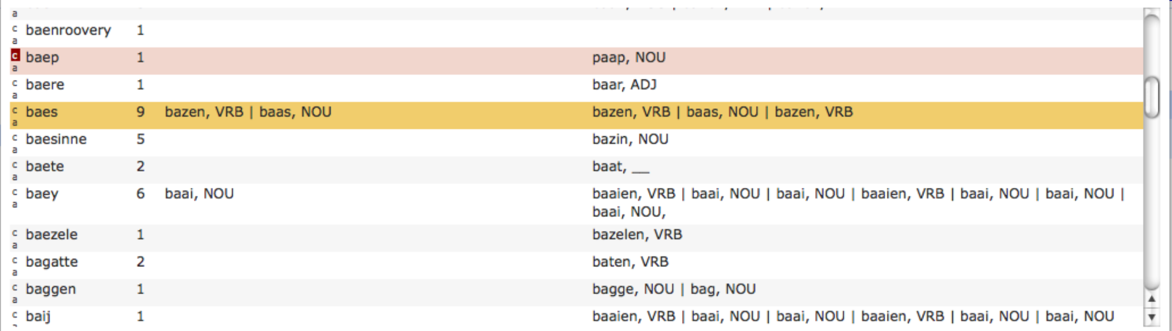
Figure 5 - partial screenshot of the IMPACT Lexicon Tool – middle part
In the middle part we see the type-frequency list with some additional options and information.
Hidden rows (see below) are displayed pink. A row is selected by clicking on it. Seledted rows, if there not hidden, will be highlighted in yellow. Only one row can be selected at the same time. Sentences in which the word form in the selected row appears are loaded in the bottom part of the screen (see next section).

Showing/hiding word forms
At the left side of each row there are two buttons labeled c and a (or d and a in document mode).
The d button (only visible in document mode) is for hiding the word form of that row for the current document. The c button (only visible in corpus mode) is for hiding the word form in that row for the current corpus. By switching on this button the row will be shown as hidden.
The a button is for hiding the word form for the entire database regardless of corpus or document. “Never show me this word again!”
When a new filter is applied or the user logs in again (when, in effect, the type-frequency list is reloaded), the word form in question will not show again, unless the relevant show/hide button in the top bar is switched on.
E.g. the row for baep in the example screenshot is hidden for this corpus, but is shown nevertheless because also the a button is switched on in the top bar, which means, show all hidden word forms.

Analyses in this corpus or document
The column right of the frequency displays all analyses the word form has in the current corpus or document (depending on the mode).
By clicking on the column it becomes editable, allowing the user to add/delete analyses. These analyses will be applied to the selected sentence(s) in the bottom part of the screen that will in turn become validated (shown by the checkbox being checked).
When no row is selected the new analyses will be applied to all rows, but they will NOT become validated.
The idea behind this that it is in this way easy/fast to apply a certain analysis to all sentences without really having to look at any of them (which is why the won’t become validated). If the user goes through the trouble of selected one or more rows (s)he must be pretty sure about it, so the analyses become validated.

Analyses in the database
The rightmost column shows all the analyses the word has in the entire database.

Applying analyses
Analyses can be applied to sentences in the lower part of the screen by clicking on them.
The same logic goes as for the corpus/document analyses.
By clicking an analysis it will be applied to the selected sentence(s) in the lower part of the screen, which in turn all become validated. When no sentence is selected the analysis will be applied to all sentences, but they won’t become validated.

Verifying analyses
Analyses can be verified or unverified. By verifying an analysis the user indicates that that particular analysis is approved of for the word form in question. Verified analysis are displayed in bold in the tool. When a token token attestation is done for a sentence or a sentence is verified, the analyses associated with the wordfrom in those sentences automatically become verified.
Anylyses can also be (un)verified 'by hand' by v-clicking on them (clicking while holding down the 'v'-key (for verify)).
Note that it is not necessary for a verified analysis to have a token attestation.

Deleting analyses
An analysis can be deleted for a certain wordform by d-clicking on it (clicking while holding down the 'd'-key (for delete)). As a consequence of course, the analysis disappears as well for any token attestation it featured in.

On word form analyses
With analysis in this context we mean head word-part of speech-gloss tuple (you might think of this as a lemma, although lemmata usually contain more information). In future releases derivation/morphological/inflection rules might (might !) also be included in this definition.
The bottom part of the screen shows sentences in the corpus/document. By applying word form analyses to these sentences the word forms become attested. As said earlier, the middle column in the middle part of the screen shows the analyses every word form has in the current corpus/document. So these will match with the ones in the bottom part of the screen. The analyses in the rightmost column however do not necessarily show anywhere, which may be a source of confusion. This can however be the case if these analyses were for word forms in a document in the same database but in a different corpus, or because they are not associated with any word form in context at all (i.e. the analysis is associated with the word form, or it wouldn't show in the first place, but there is no attestation in context anywhere yet). The latter can e.g. be the case when a database comes preloaded with information form an external lexicon/dictionary.

As said above, analyses can be deleted and verified. This allows for a three way workflow with regard to analyses:

Wrong | Delete the analysis
Not sure (yet) | The analyses is there but not bold
Validated | It shows bold

Another way of seeing things is this:

 | validated | not validated
attested |  | not applicable
not attested

When starting from scratch, word forms will typically be in the lower right corner where they are neither attested nor validated. Usually, you would want them all to end up in the upper left corner, where they are both attested and (hence) validated.
Do note however that it is possible for an analysis to be validated for a word form even though there are no attestations to prove it (by just v-clicking on it). It could be that you want this for a case where an analysis is completely clear and obvious but your corpus is e.g. too small and coincidentally had no sentences in which it occurs. It could also be of course that you never ever want unattested anlyses to be verified. Whether or not you use this feature is left to the user. The tool merely gives you the possibilty to do so.
It is always easy to see when an analysis is verified but unattested as it will not be listed in the middle column while it is displayed boldly in the right one.
Also, it is of course very easy when compiling a lexicon from the database, to extract only those analyses that do have attestations.

In terms of the table above again, it looks like this:

 | validated | not validated
attested | bold  shown in middle column | not applicable
not attested | bold  not shown in middle column | not bold  not shown in middle column

Bottom part
The bottom part shows the sentences in the corpus/document in which the word form selected in the middle part appears.

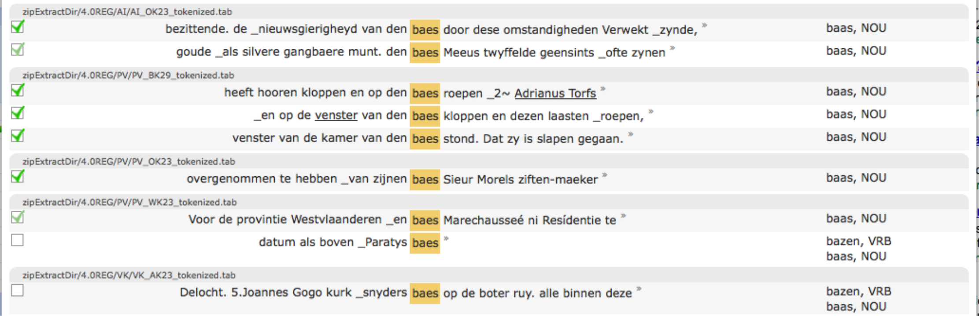
Figure 6 - partial screenshot of the IMPACT Lexicon Tool – bottom part

Validation
By applying an analysis to a word form in the lower part of the screen (either by an action in the middle part as described above or by choosing an option form the drop down list as described below) the analyses for this word form in the document become validated. This is is to be interpreted as 'the user saw the word form in this context and approves of the listed analyses'.
Word forms in their context can be validated (regardless of whether they have an analysis or not) by checking the validation box. Or they can be un-validated by unchecking it.
As with any other action you do in this part of the screen, (de)validation is applied to all selected sentences).

When the validation checkbox is grayed out a bit (as in the second and seventh row in example screenshot) this means that the word form in this context was validated, but by a different user.

New word form analysis
By clicking on a word in its context a dropdown menu appears in which all analyses in the database are listed and the analyses in this context highlighted. By switching analyses on or off they will be (un)applied to the word form in question. Also, when the last option New… is selected a textbox will appear in which the user can type in a new analysis.
As with any other action you do in this part of the screen, any analysis you assign is also applied to all other selected sentences.
When this dropdown list is used to add or delete an analysis, the wordform in this context automatically becomes validated.
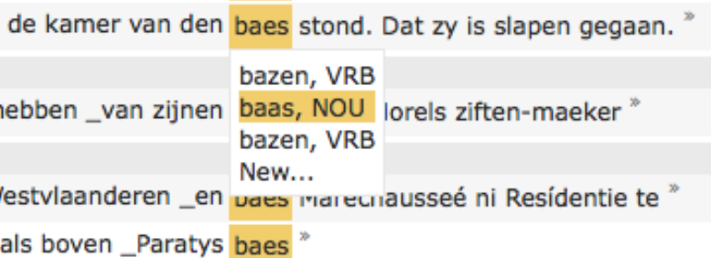
Figure 7 - partial screenshot of the IMPACT Lexicon Tool – close up of analyses drop down menu

More context
The user can see more context by clicking the » at the right of the sentence. A pop up window will appear in which more context is shown. In this window the user can be shown even more context. Or even more, as long as there is more context to show.

Word form analyses
The rightmost column shows all current analyses for the context. Clicking on one of them will result in this analysis being deleted for the row it is in, and also for any other selected sentence it featured in.

Selecting sentences
You can select sentences by clicking and dragging in the left half of the sentence (left of the highlighted word). By a-clicking a sentence (click while holding down tha 'a' key) you select all sentences.
A sentence is deselected by clicking on it.

